LAB/TUTORIAL 1

ADVANCED SOFTWARE ENGINEERING

This document contains the hands on experience on ScrumDo, GitHub and UML Diagrams of Class, Sequence and Architecture Diagram using Visio Tool.

2013

Karthik Repala

16144888

8/28/2013

**ScrumDo**

1. Create a ScrumDo account, perform the tasks shown in Tutorial 1

The following are the steps performed in the ScrumDo.

Step 1: Login to ScrumDo if account exists or sign up if there is no account.

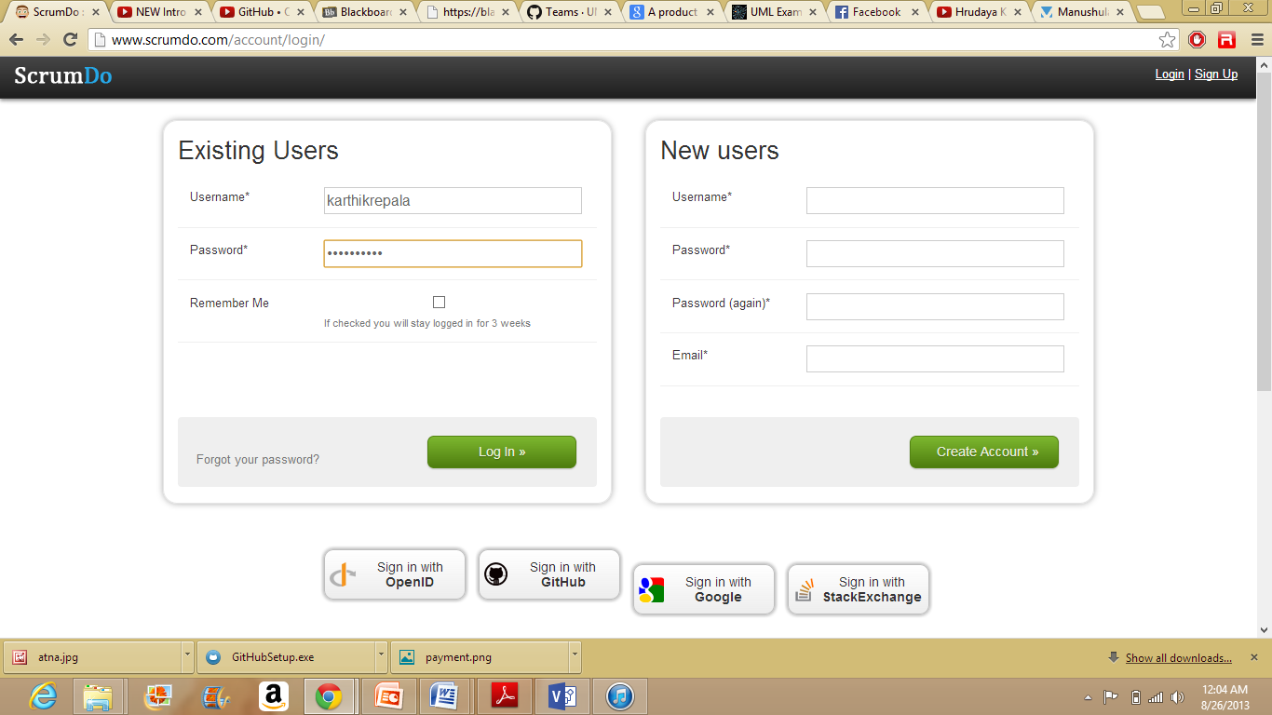

Step 2: Story Creation.

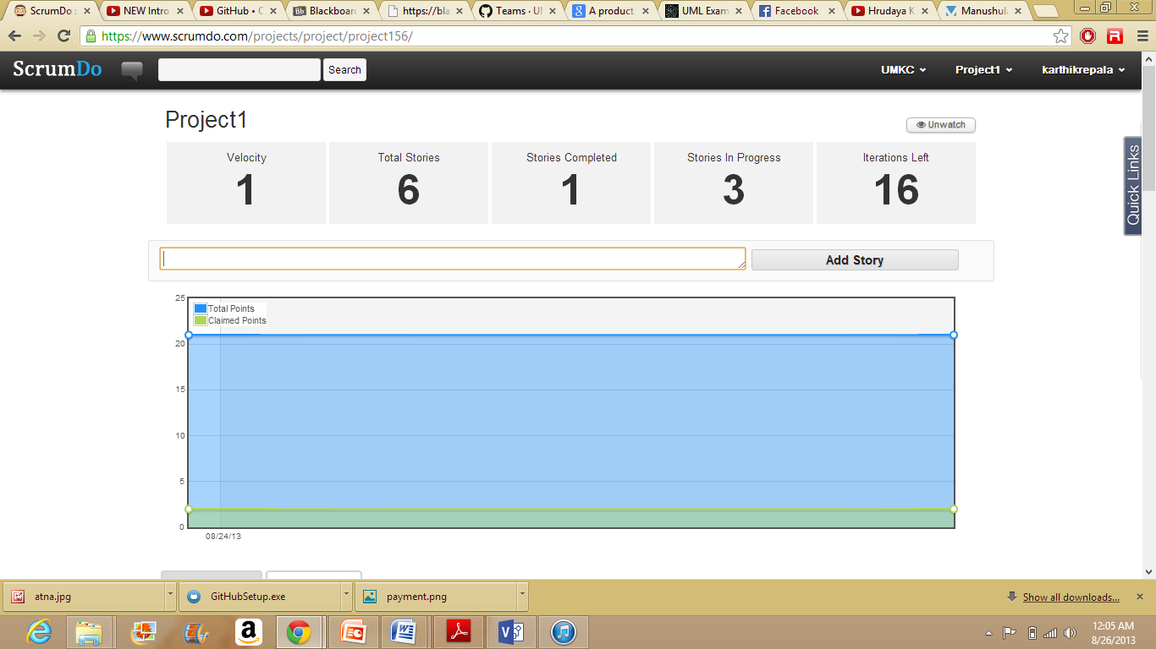

Fill in the details as shown below to create a story.

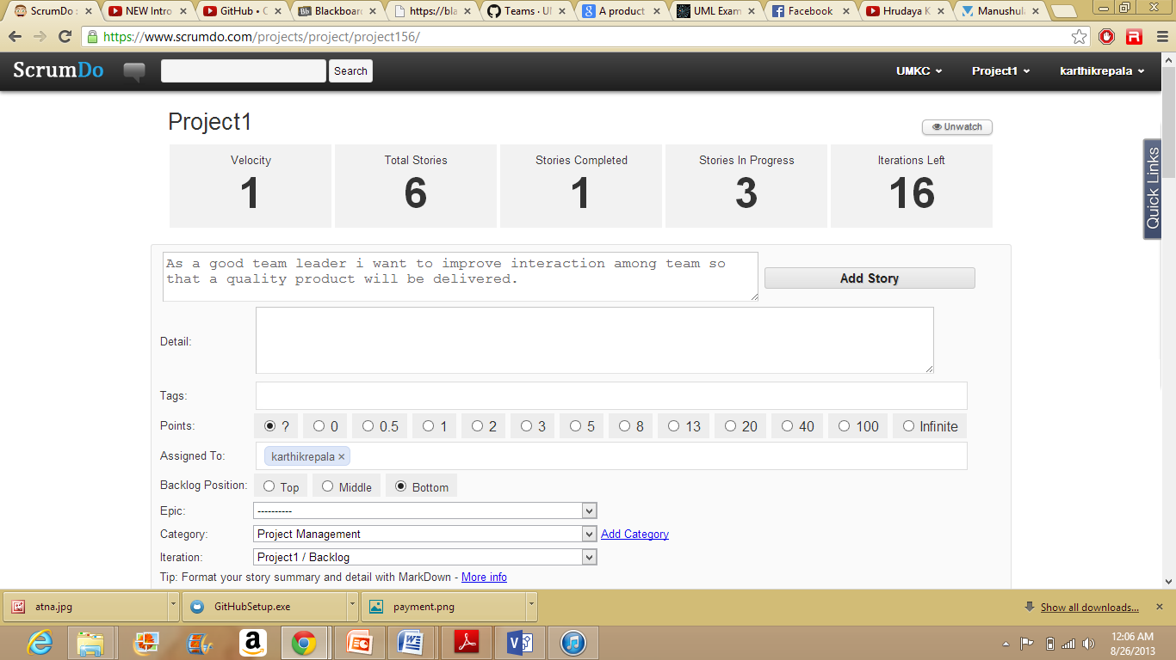

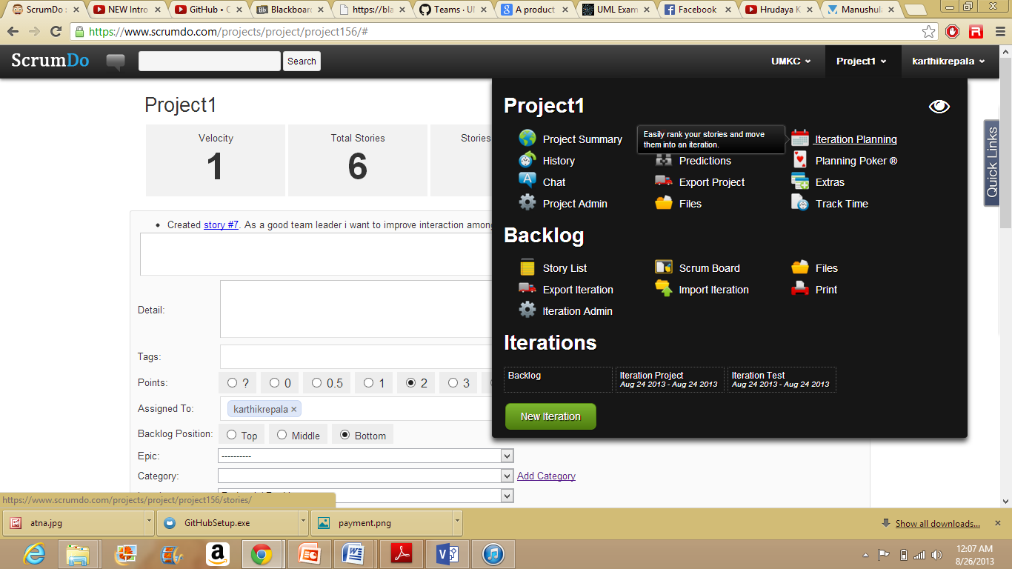

Backlog shows the list of stories that are in To do phase.

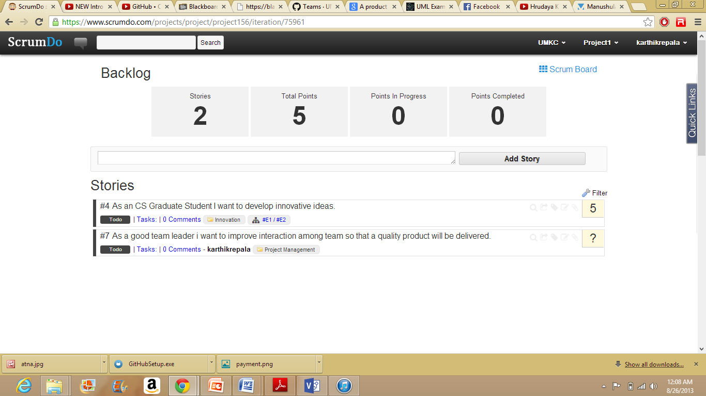

Step 3: Create Iteration.

Click the New Iteration Button to start a new iteration.

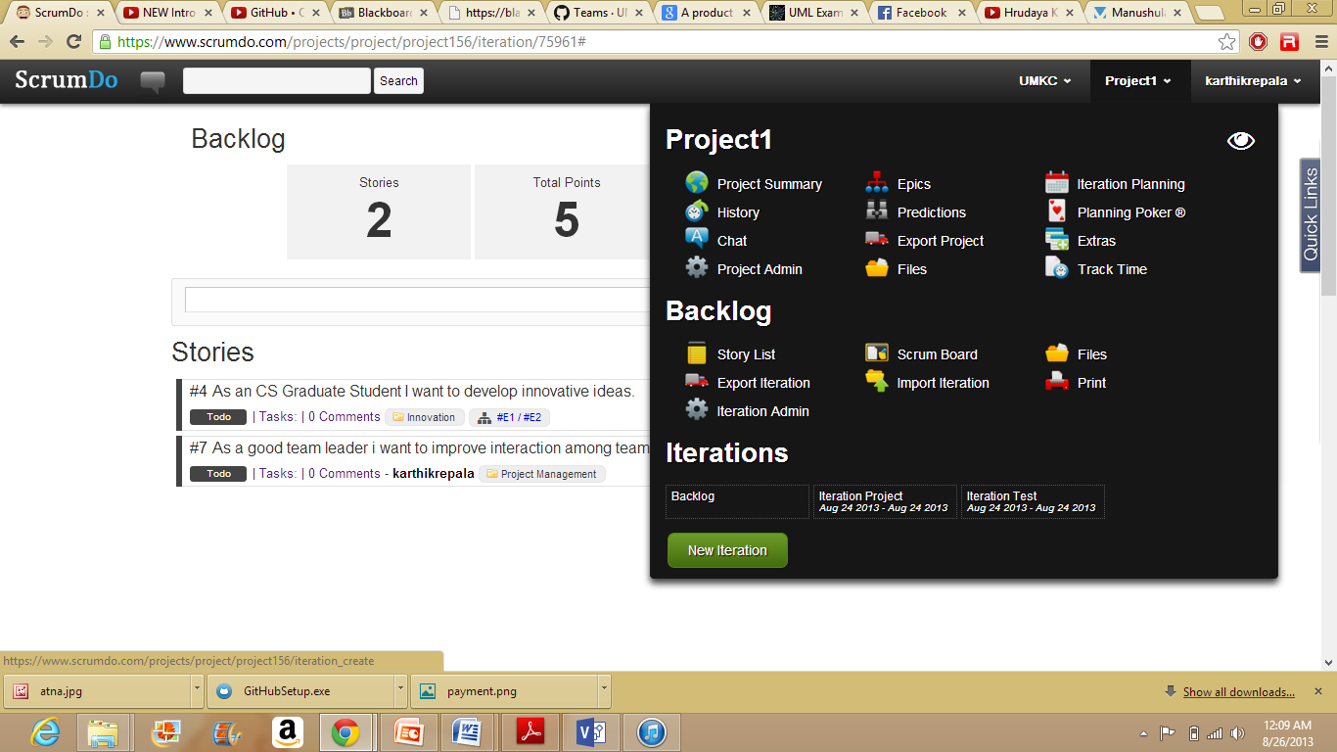

Fill the details in the below form.

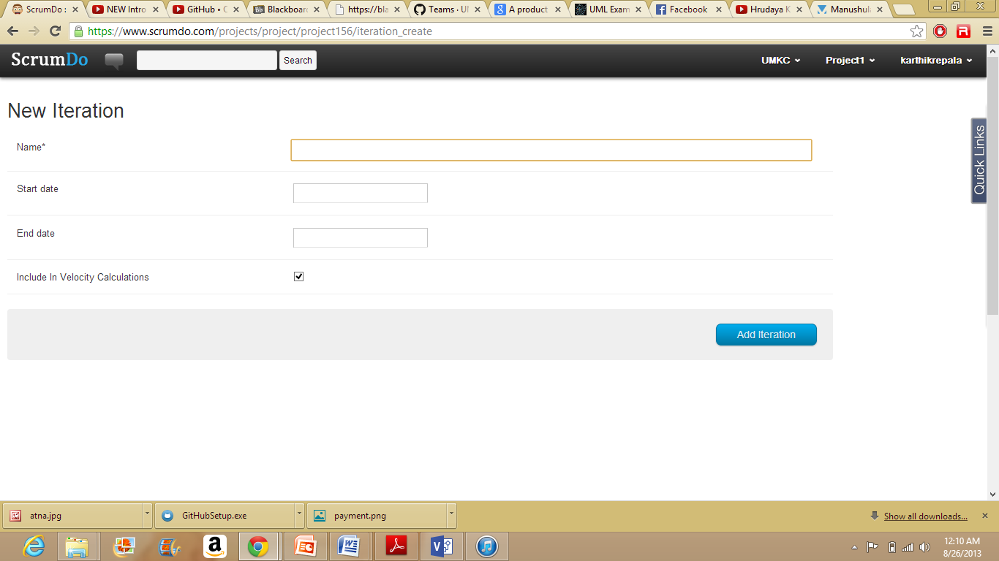

Iteration once filled will be displayed as shown below.

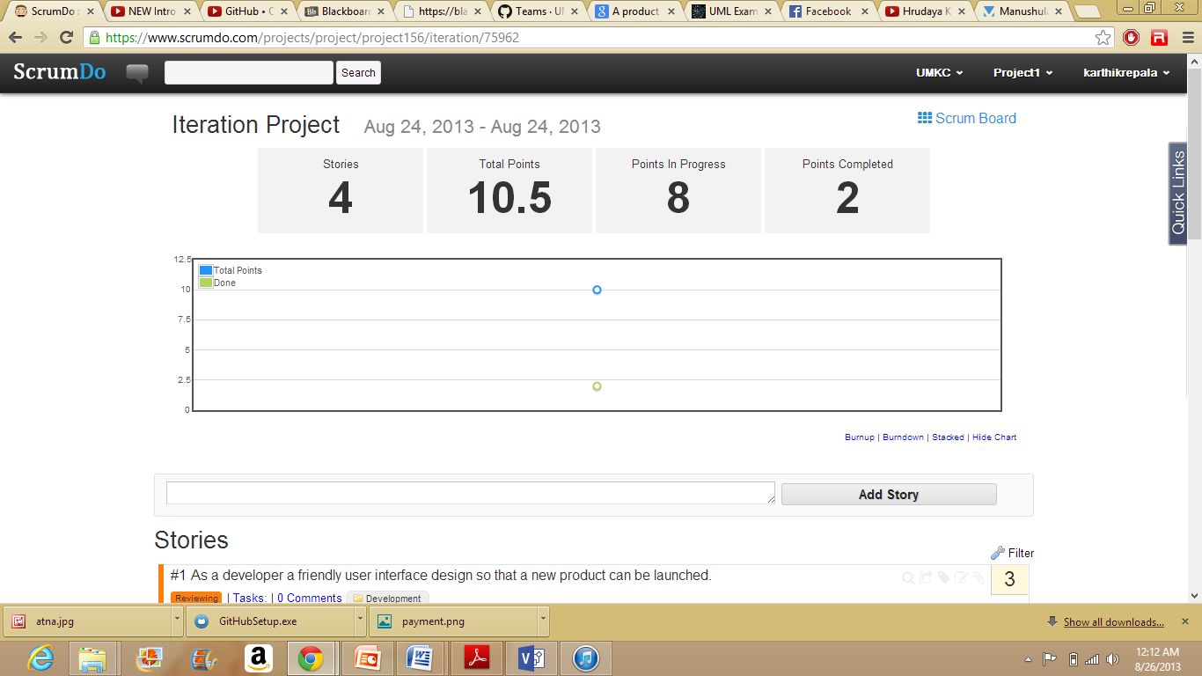

Step 4: Iteration Planning is used to place the stories into an iteration.

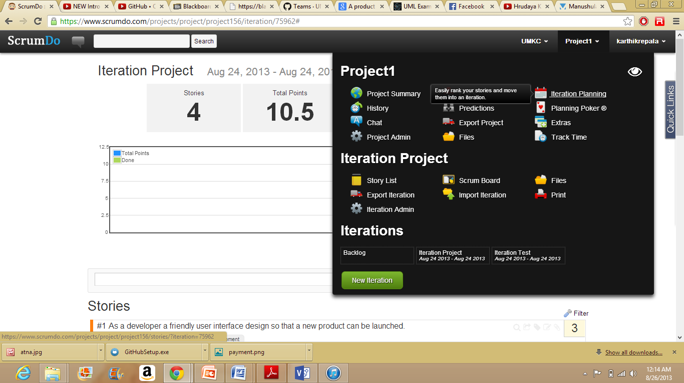

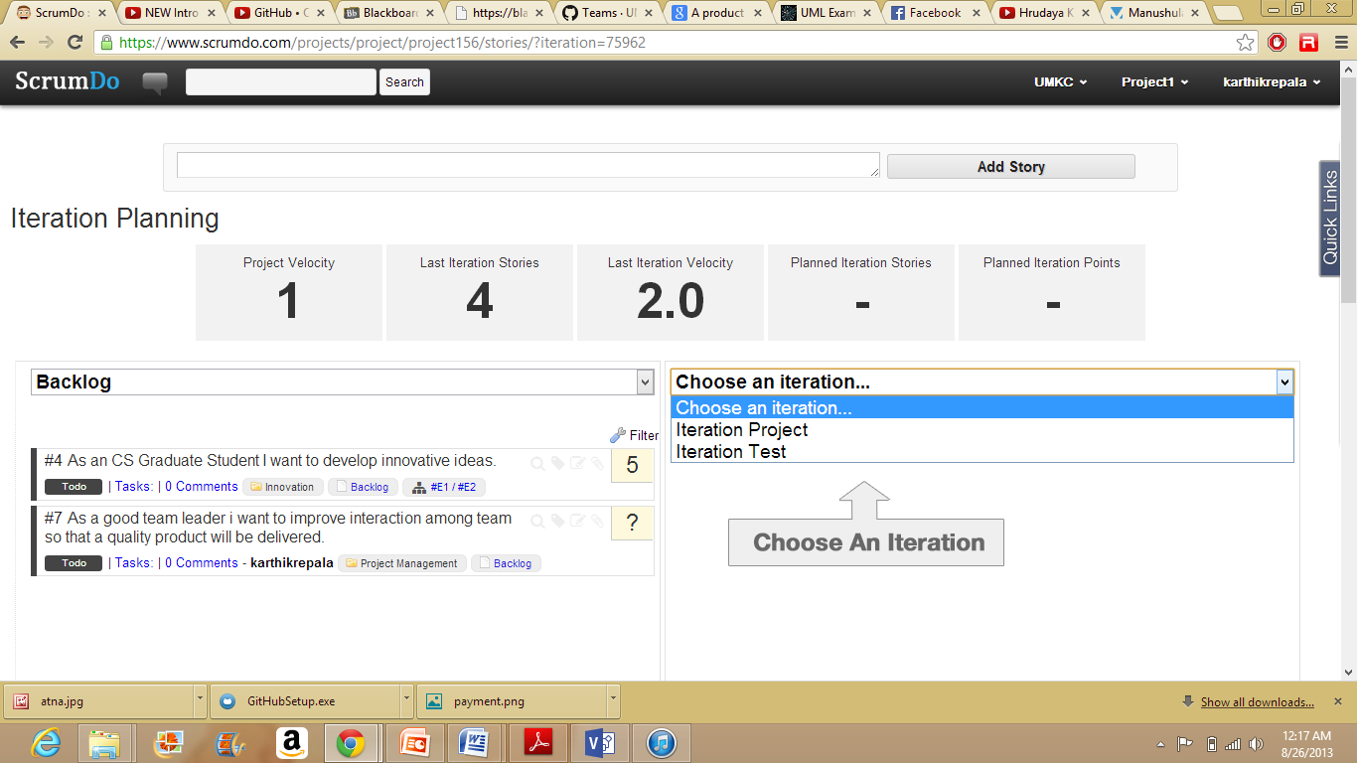

Step 5: Epic Story Creation.

Epic Story is a story that contains too many unknown to tell how large it is, or can be said as story that can't be completed in a single sprint.

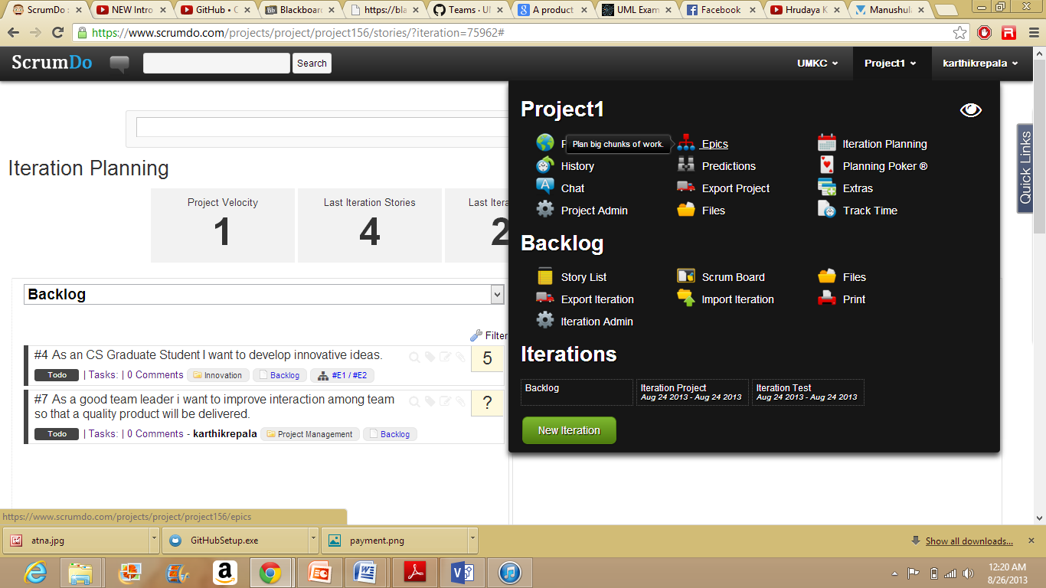

Step 6: Click on New Epic Button to begin a new epic story.

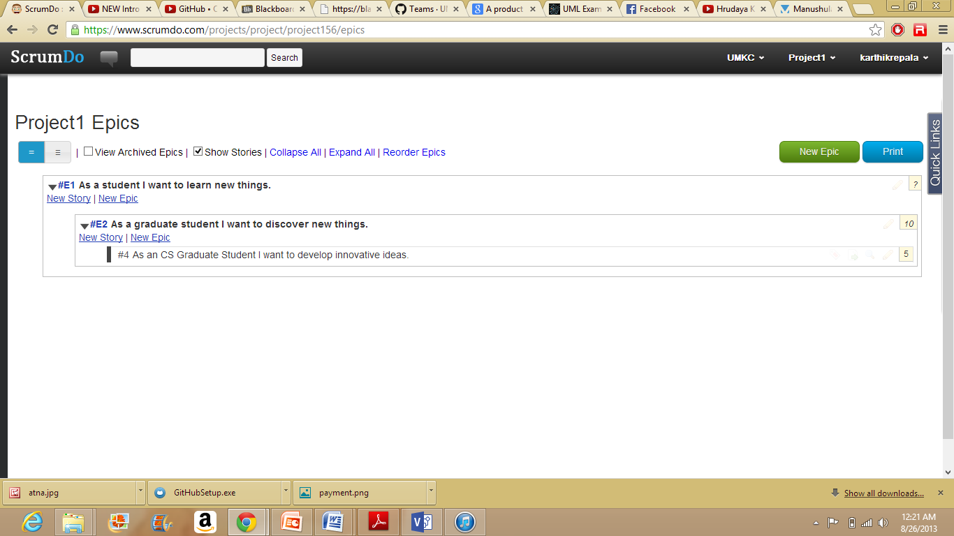

Step 7: Scrum Board.

Scrum Board displays the status of stories or can be told as it displays the current phase of the story.

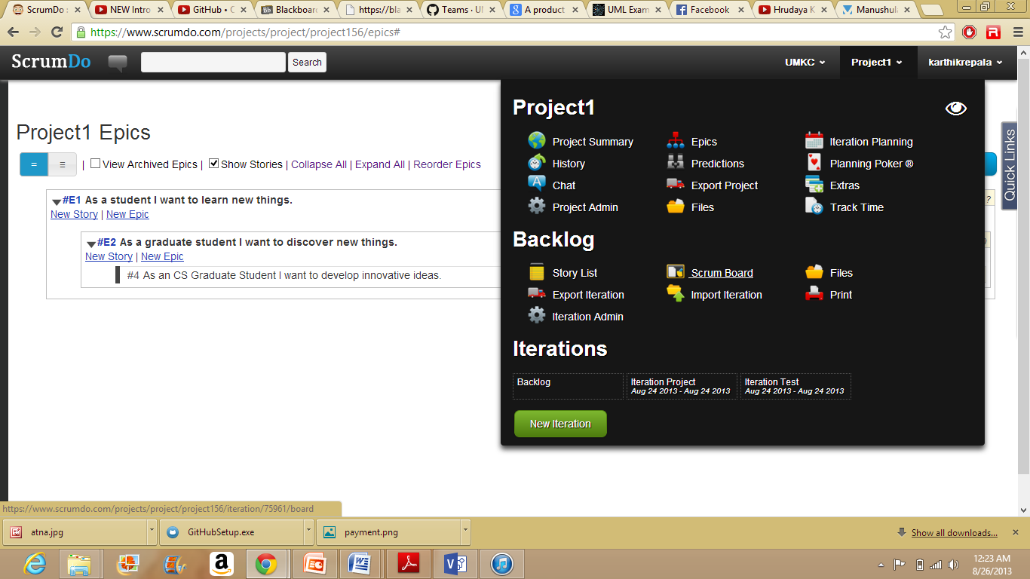

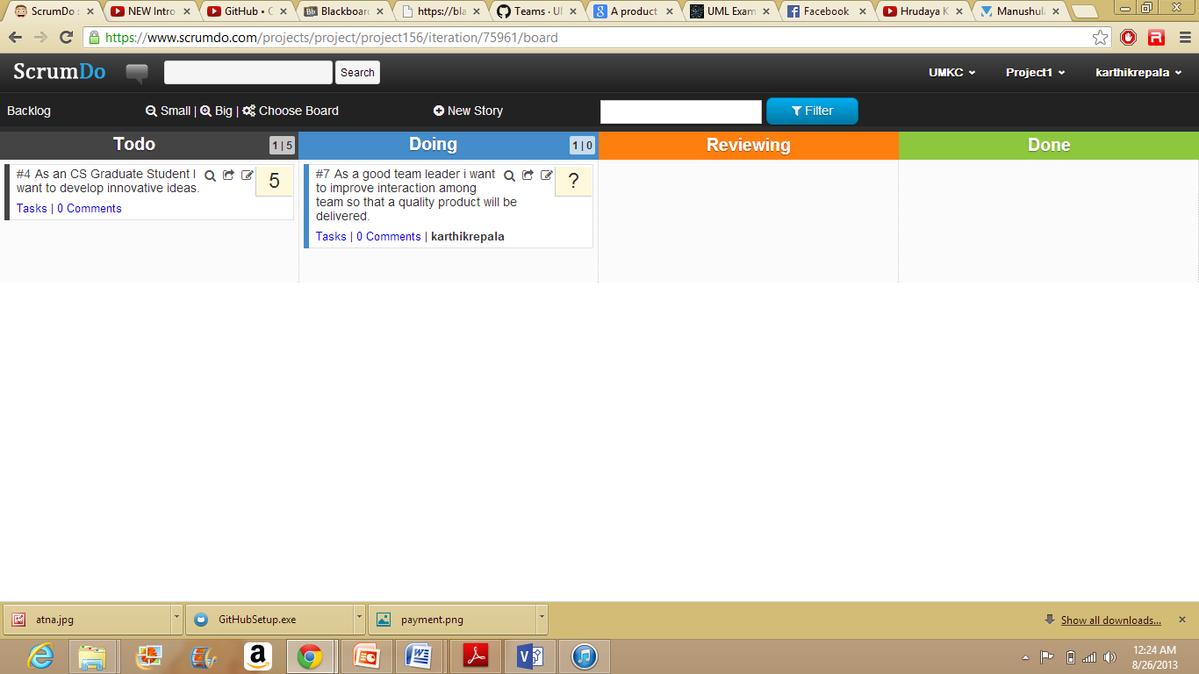

The changed content can be displayed in the project summary tab.

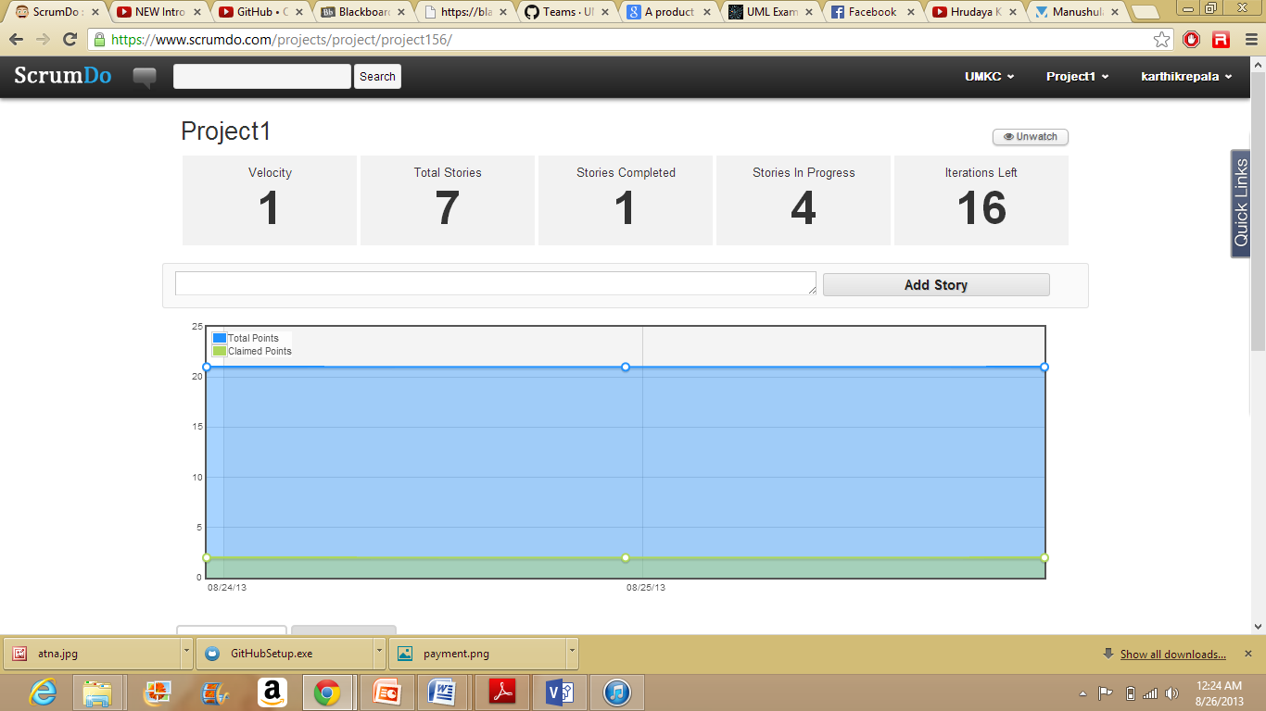

Step 8: Team Creation.

A group of people can be assigned to the team so that they can perform the required tasks.

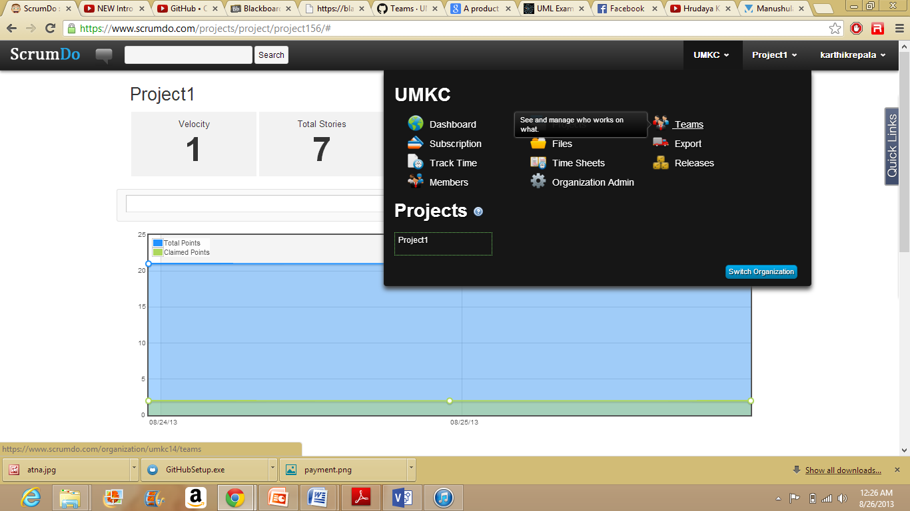

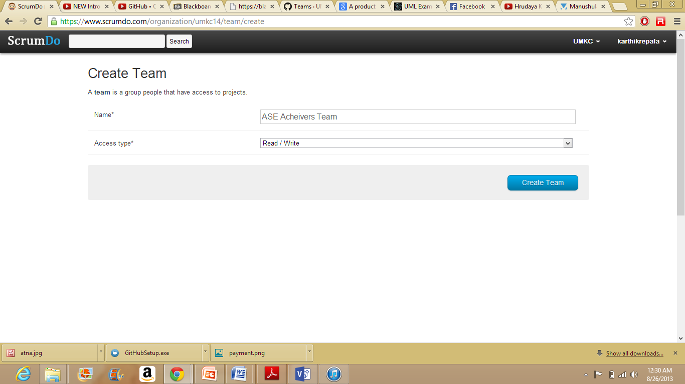

Add the people to the team by giving the team members mail id's.

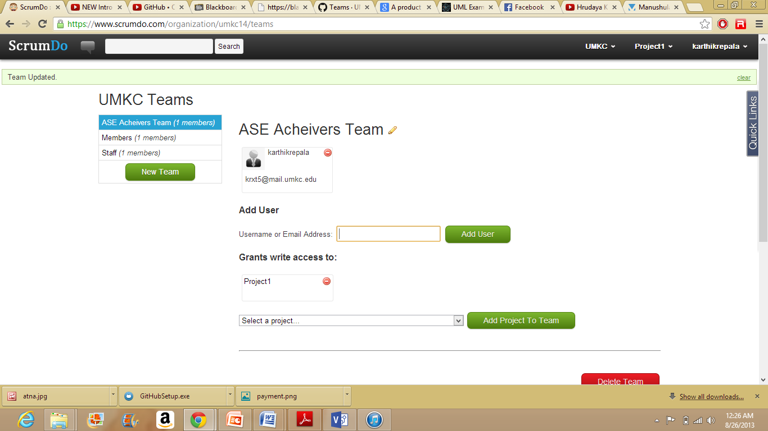

Once the details are given, the following mail can be seen in the mail box.

Hello, Someone has just invited you to the ScrumDo team ASEAchieversTeam in the UMKC organization. Please follow the link below to accept. http://www.scrumdo.com/organization/accept/xxxxx Thank you! The ScrumDo Staff

After the user clicks on the below link, the team member can access the project.

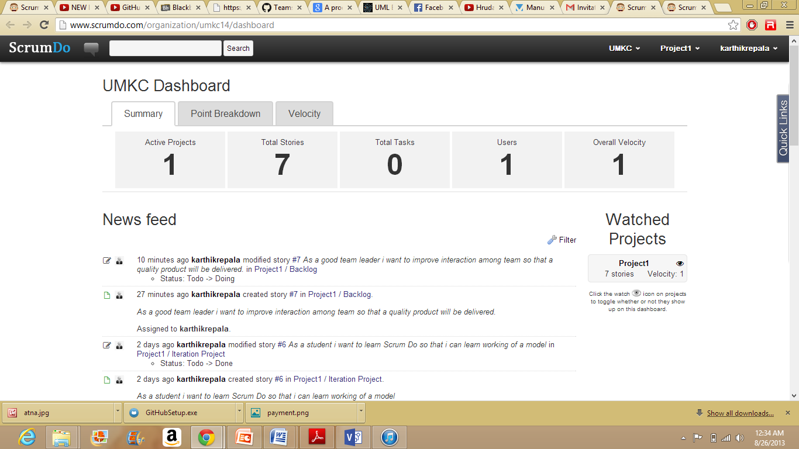

**GITHUB**

2. Create a GitHub account, perform the tasks shown in Tutorial 1

Creating a GitHub account.

Go to https://github.com/

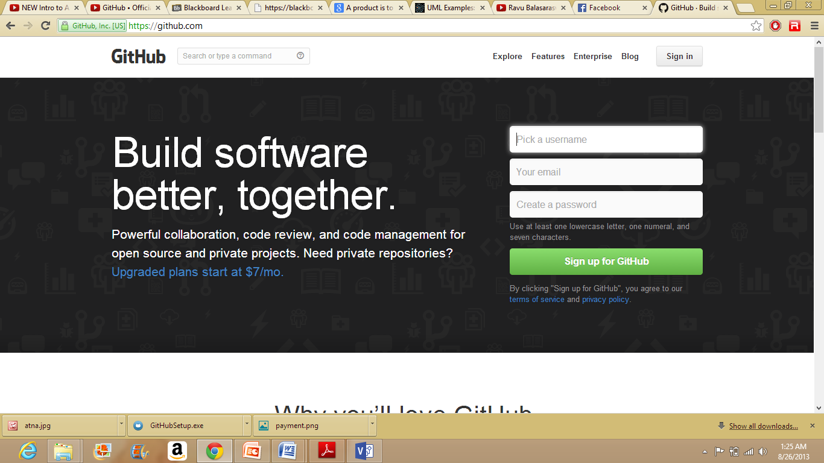

Sign up into the GitHub account

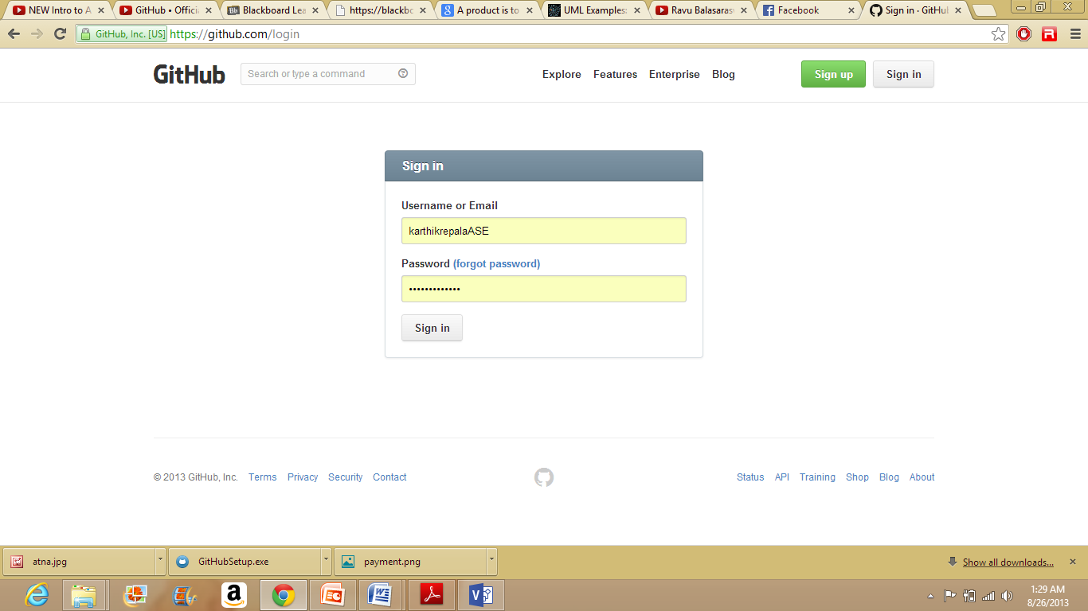

Create a repository using the New repository button as shown below.

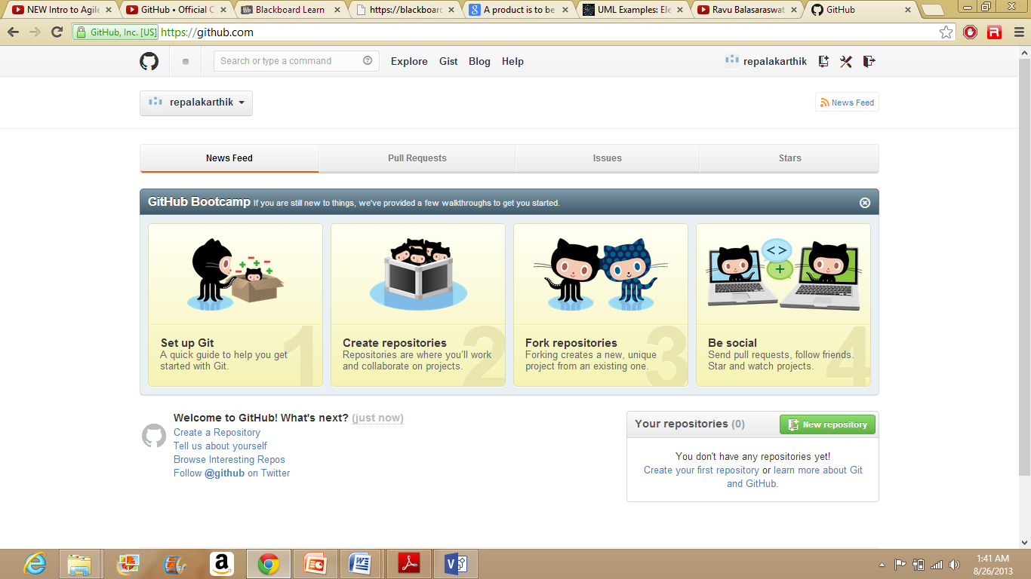

Log in to GitHub Account using the username and password.

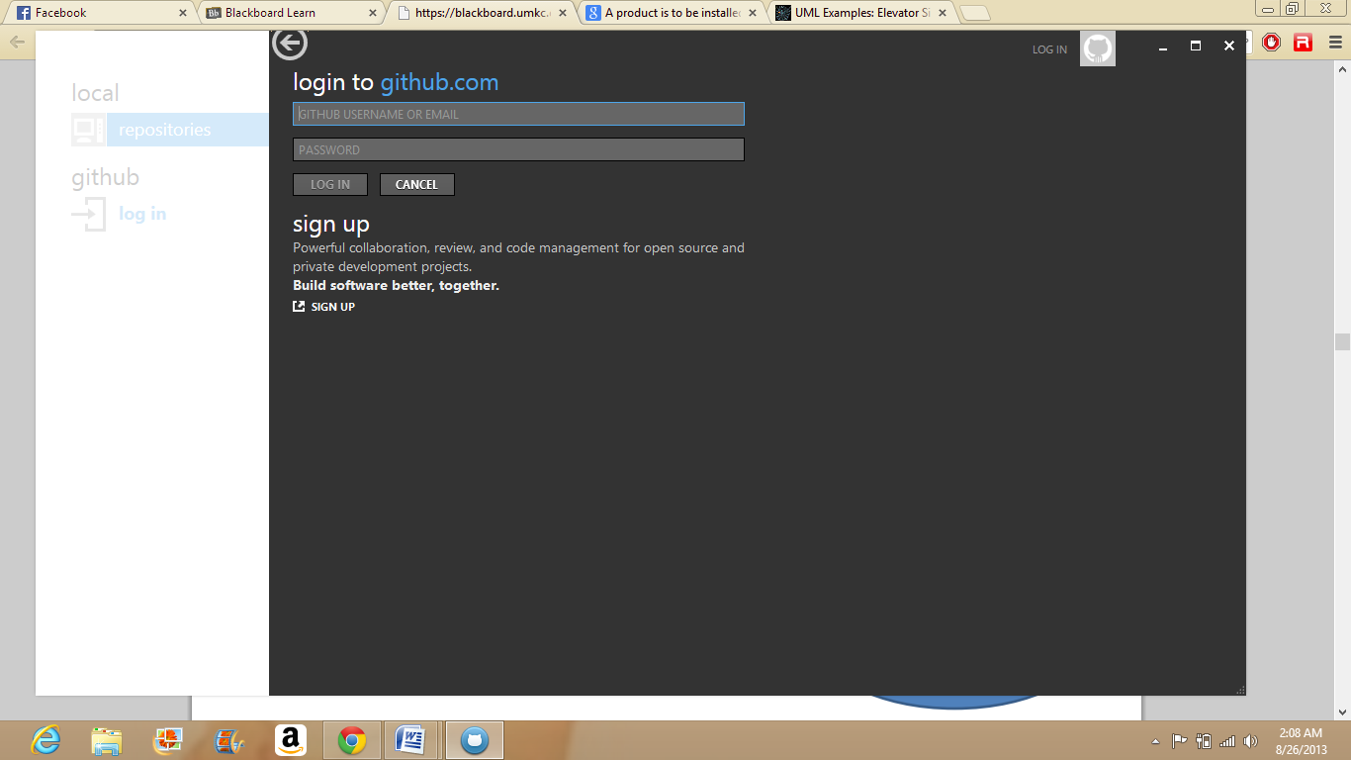

GitHub screen before cloning.

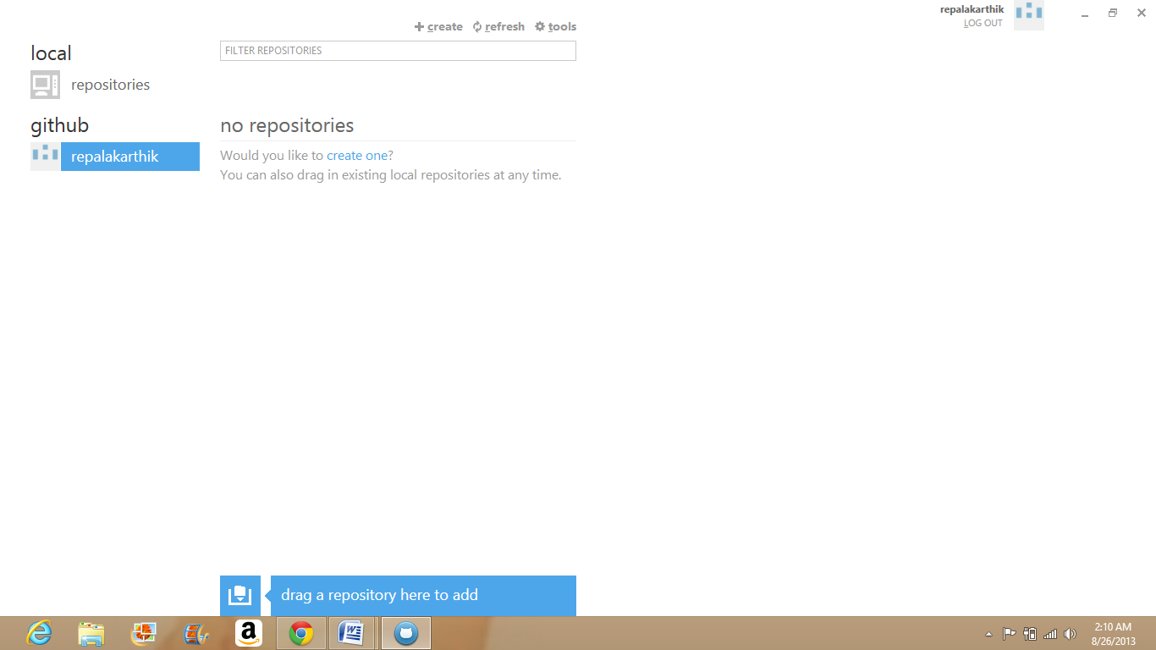

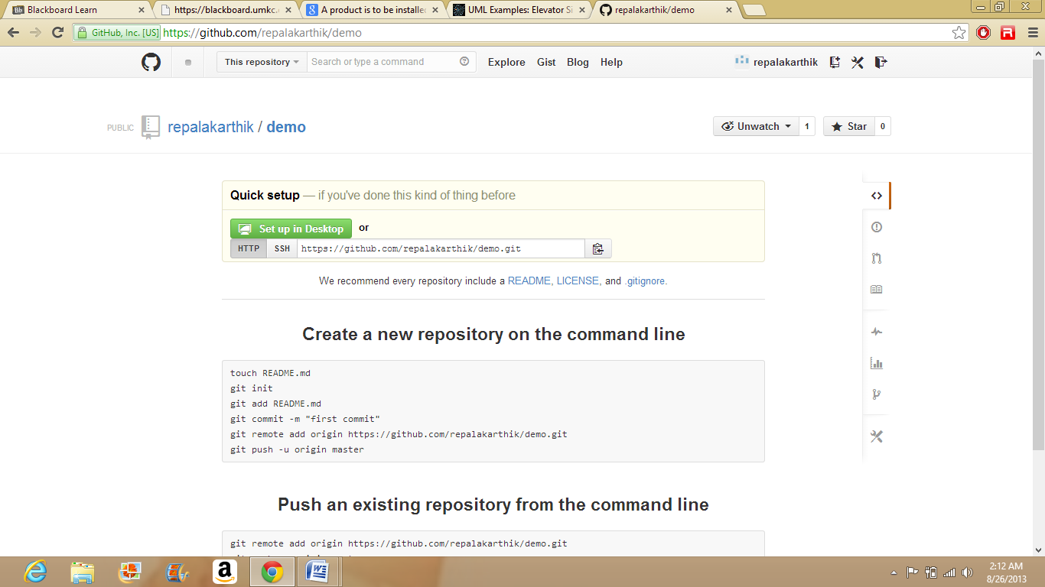

After Cloning

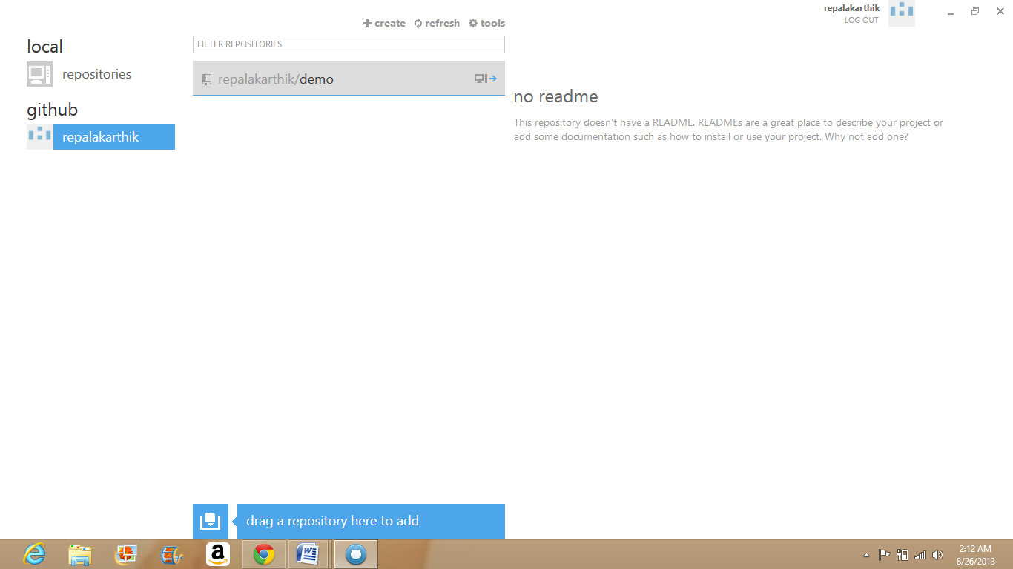

The created repository can be shown in the folder.

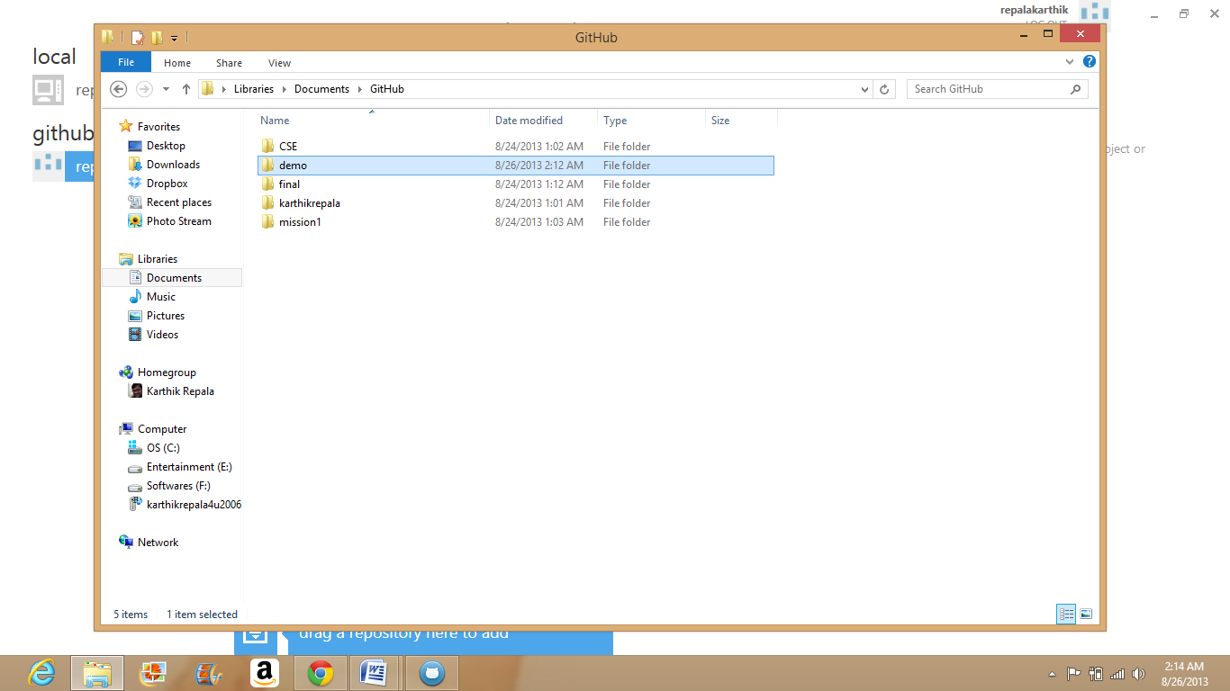

Create a file locally.

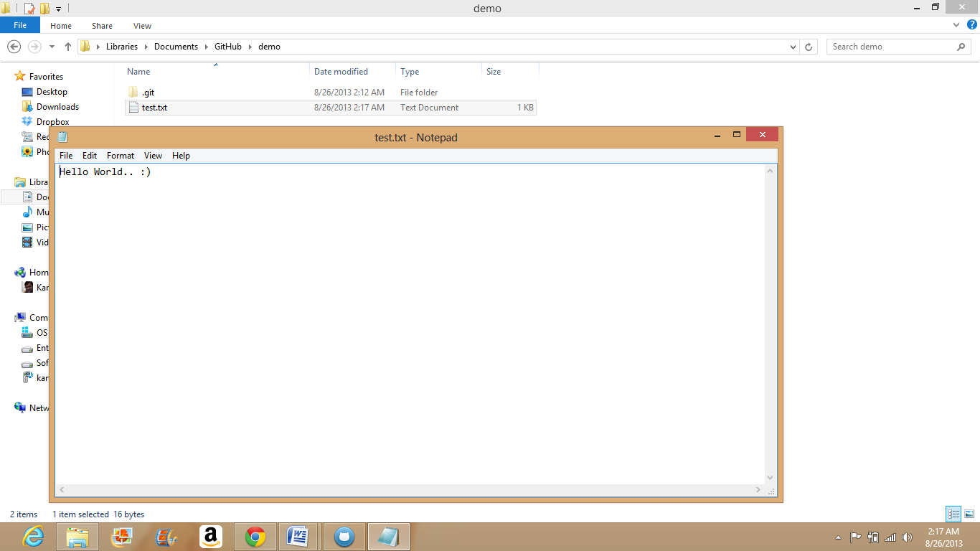

Open the repository in GitHub.

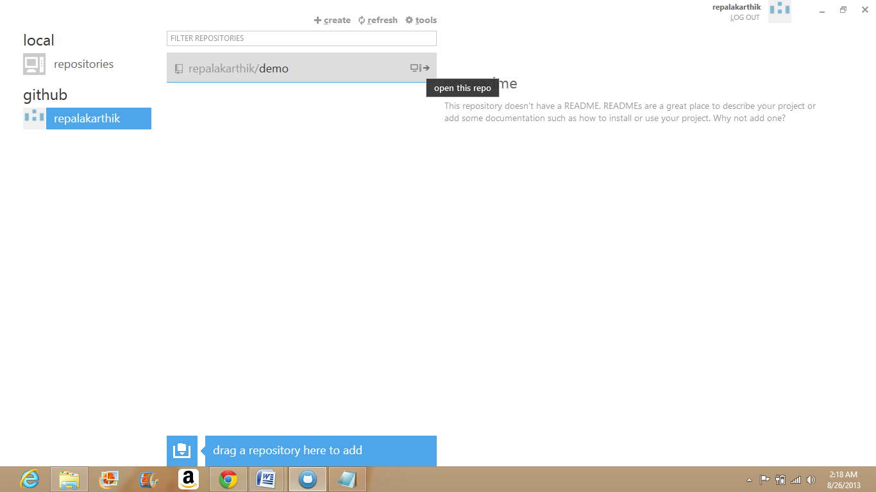

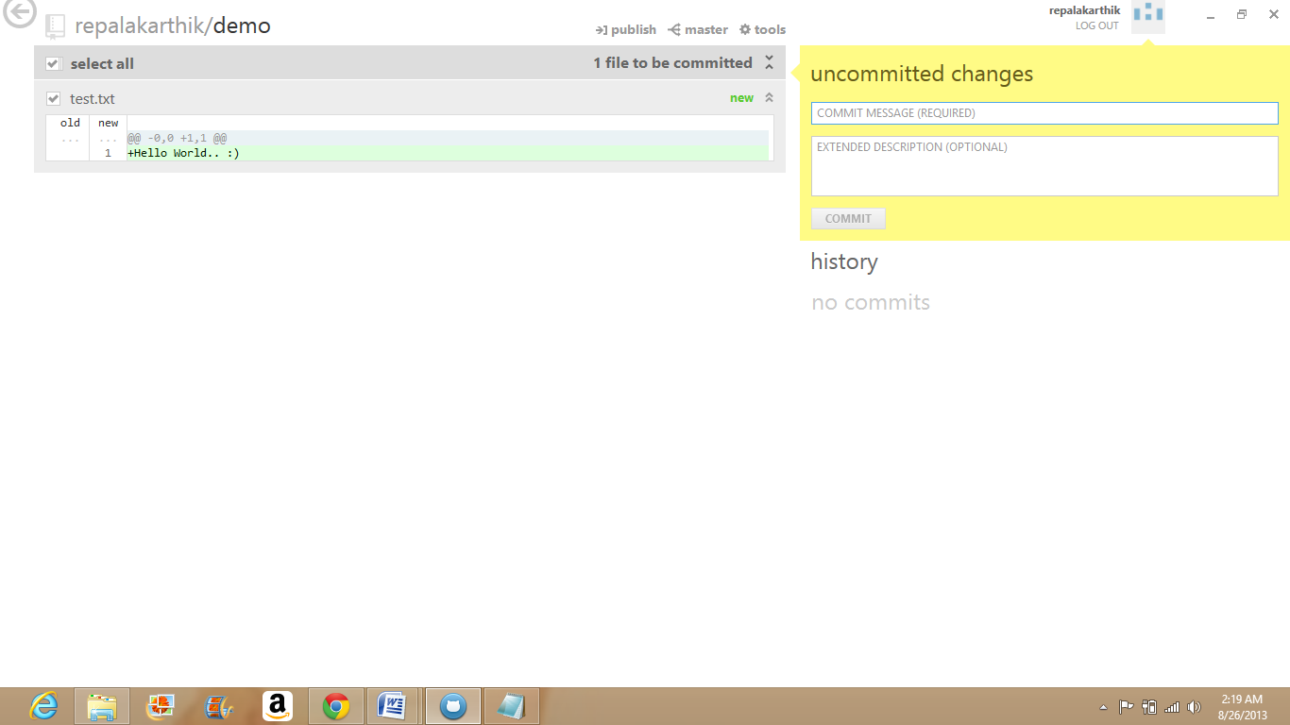

Email address associated with the account can be changed by following the path shown in the below screen.

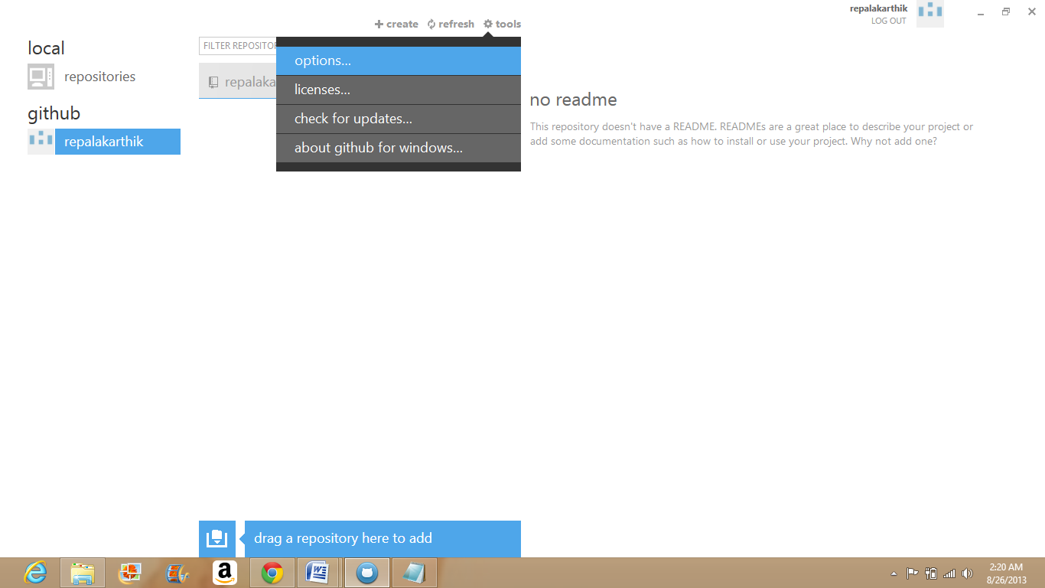

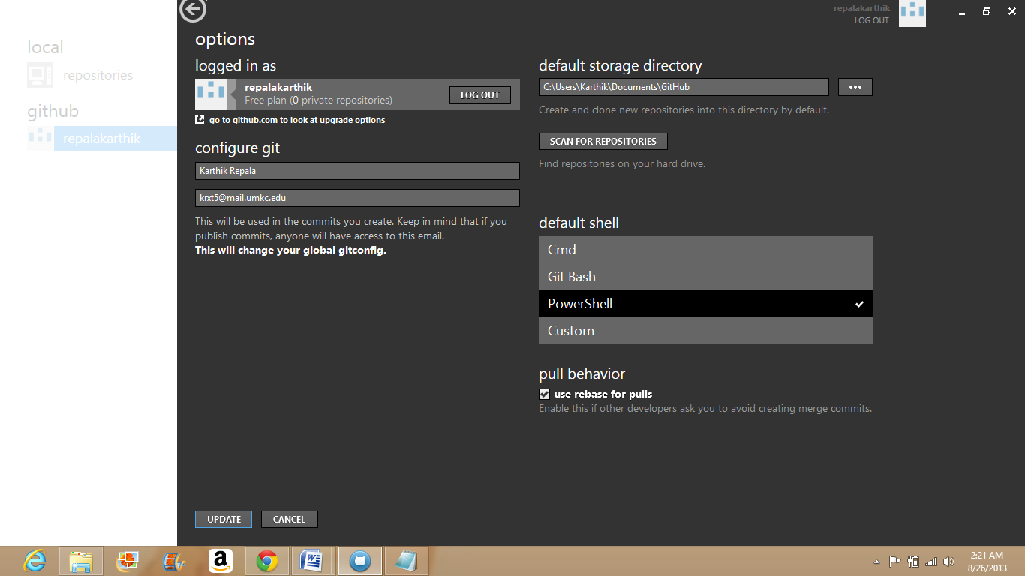

A file can be committed by giving the commit message name and description.

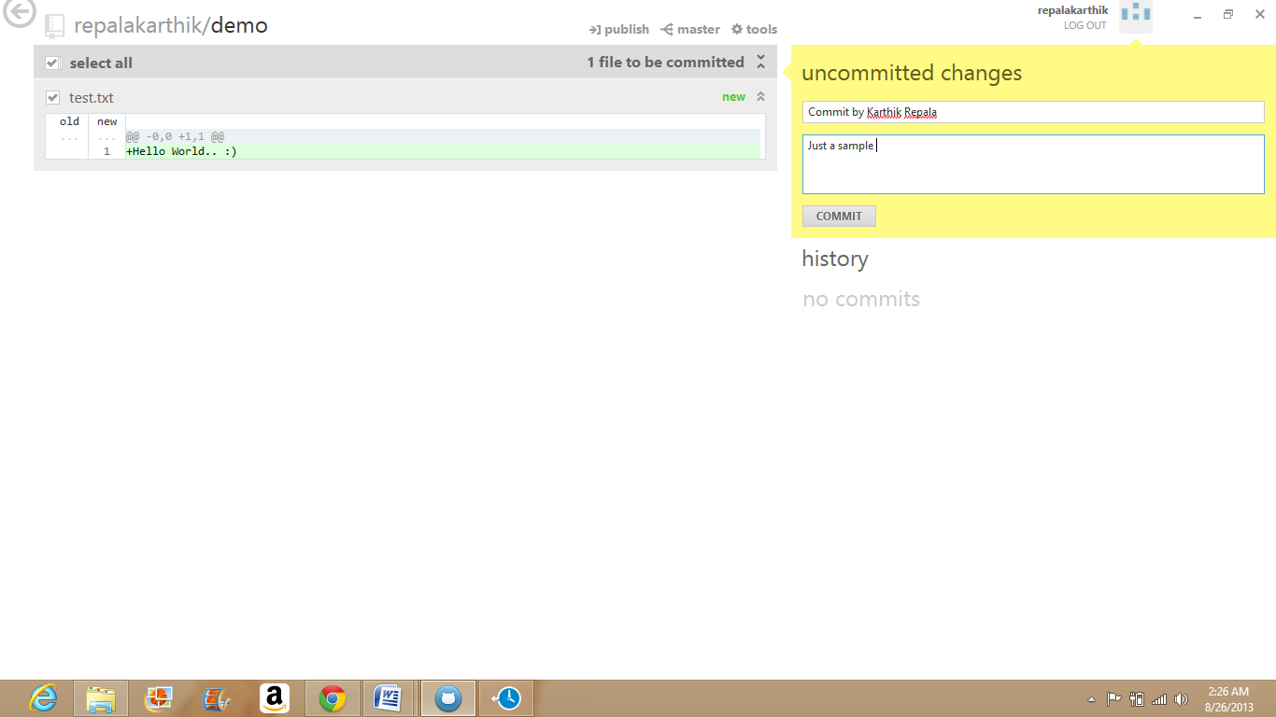

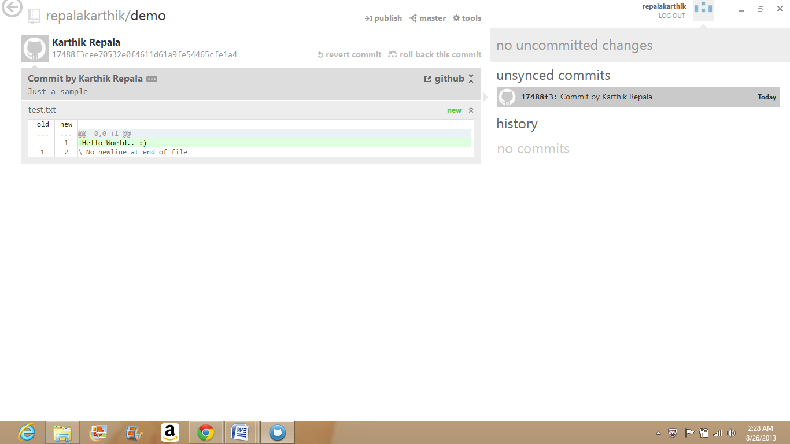

The document publishing can be done using the publish button in the screen above.

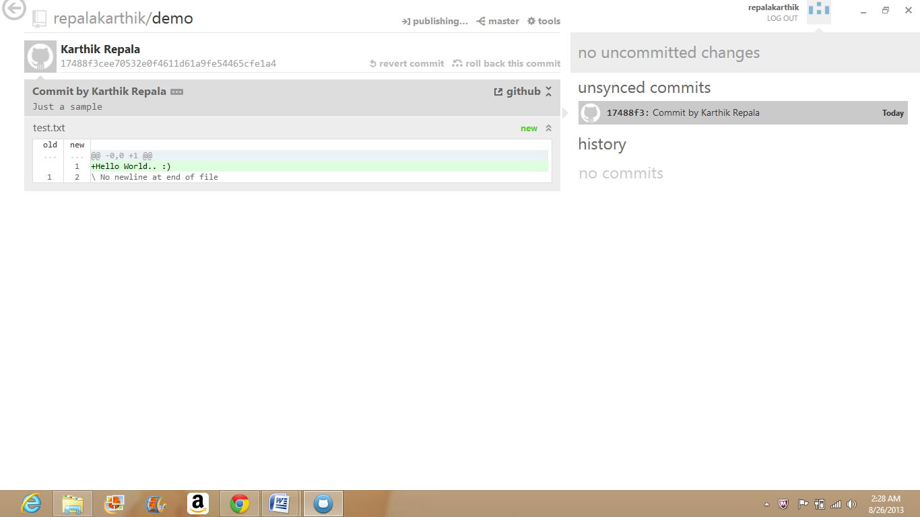

The document which is in sync is displayed on the top of the screen.

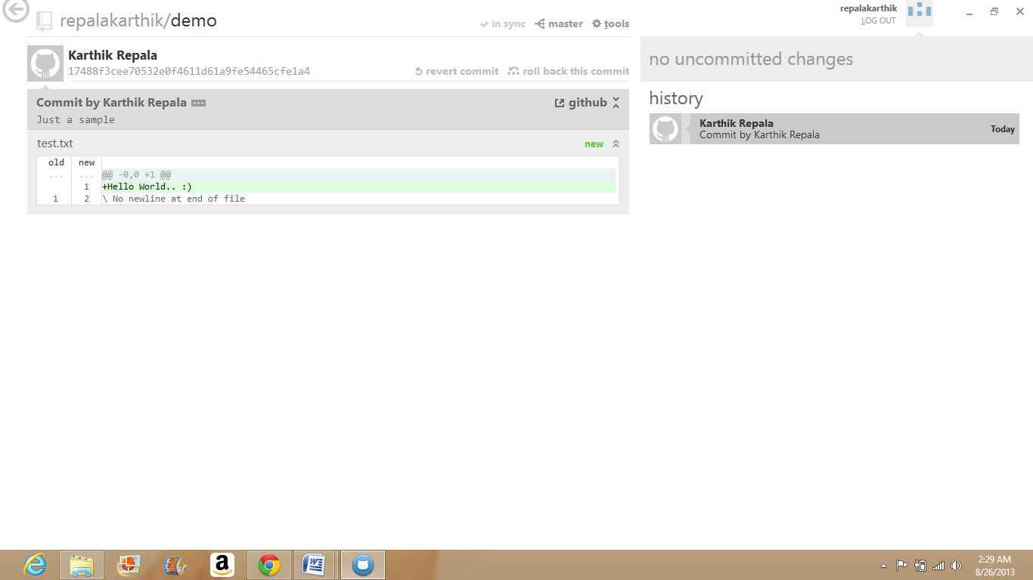

Creating an Organizational account.

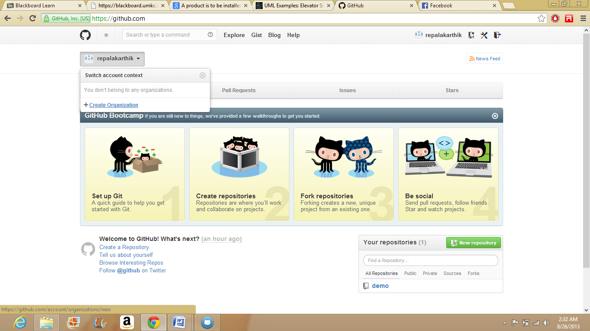

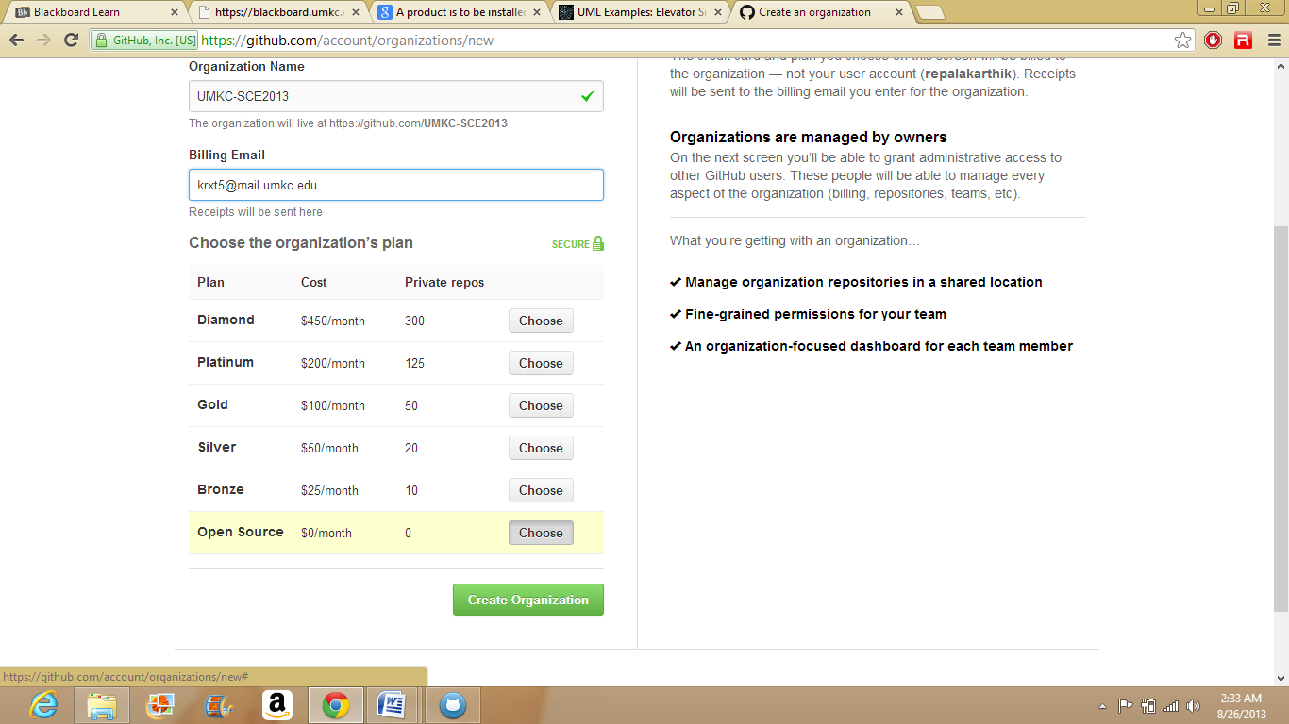

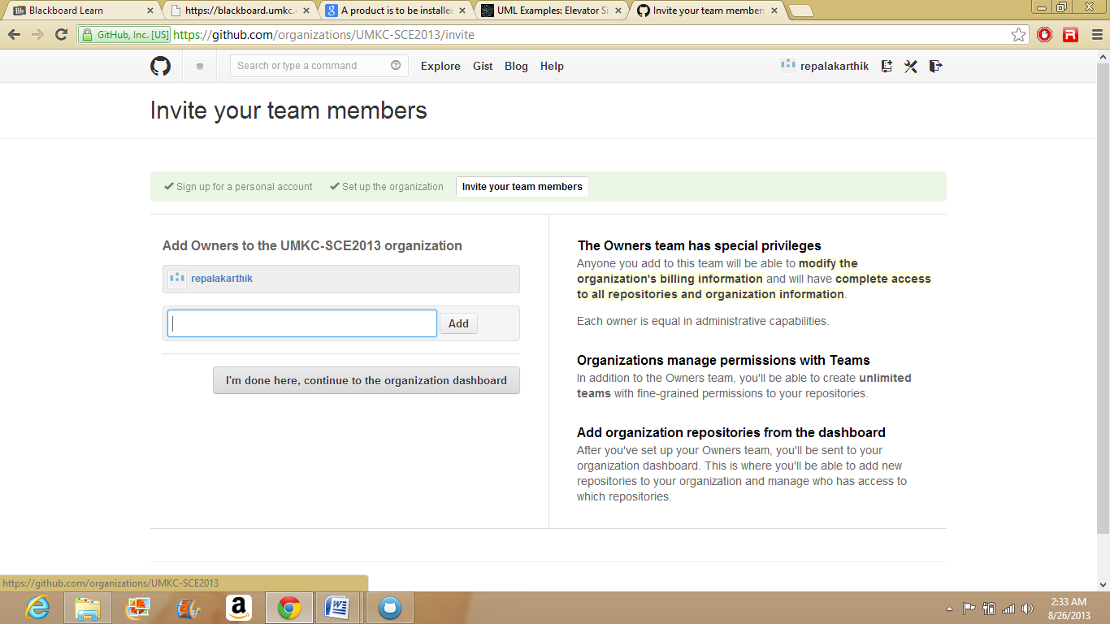

Adding Team Members.

The settings of account, organizational account, member, team management etc can be changed into the settings of GitHub account.

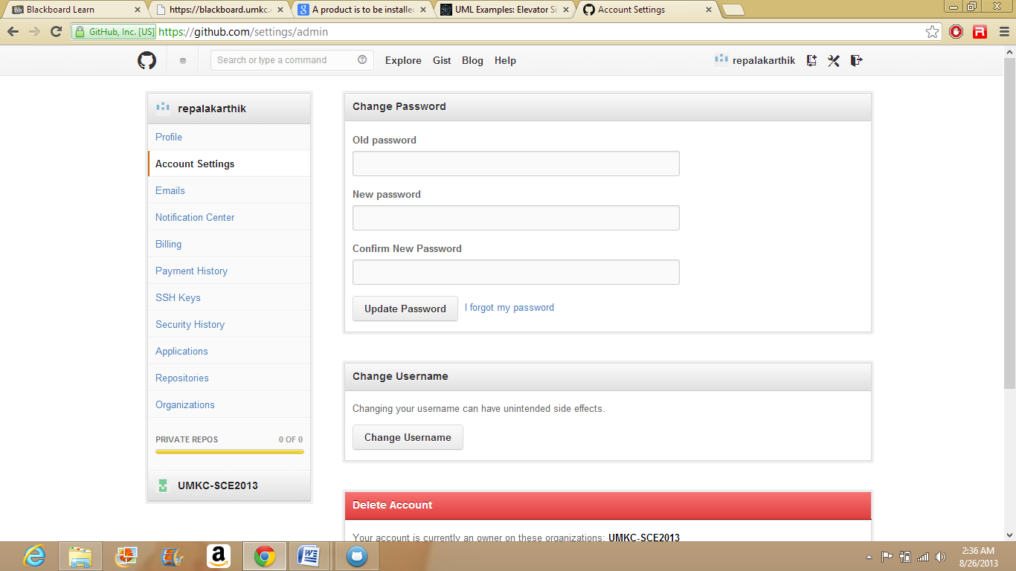

Adding new members to the team.

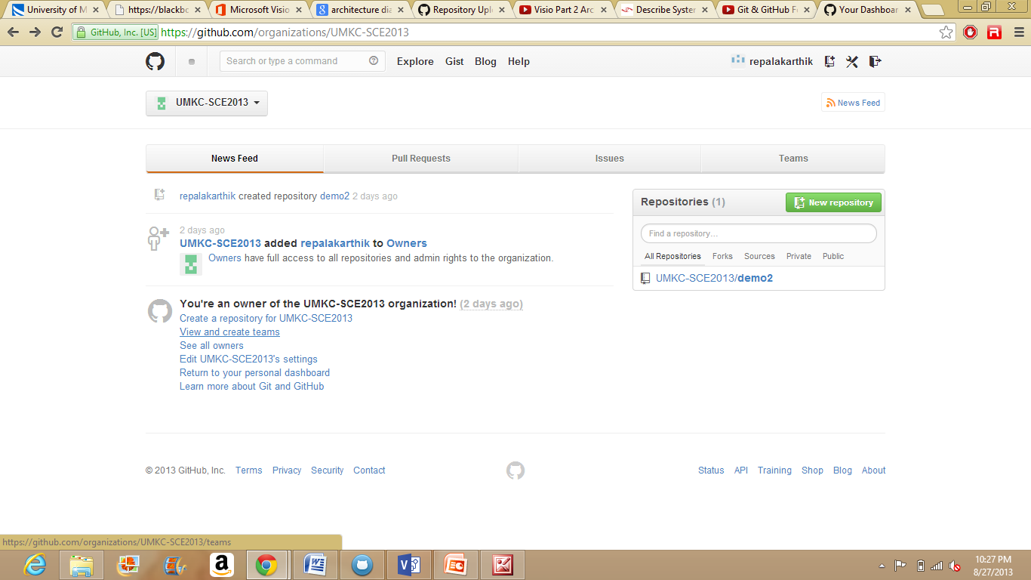

Add the team members name in the Members Column and click on add.

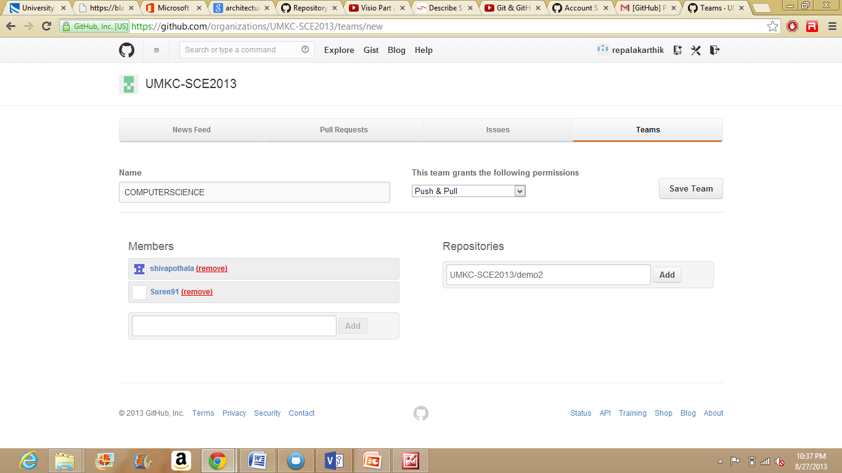

Logging as different team member. i.e. with the organization account created.

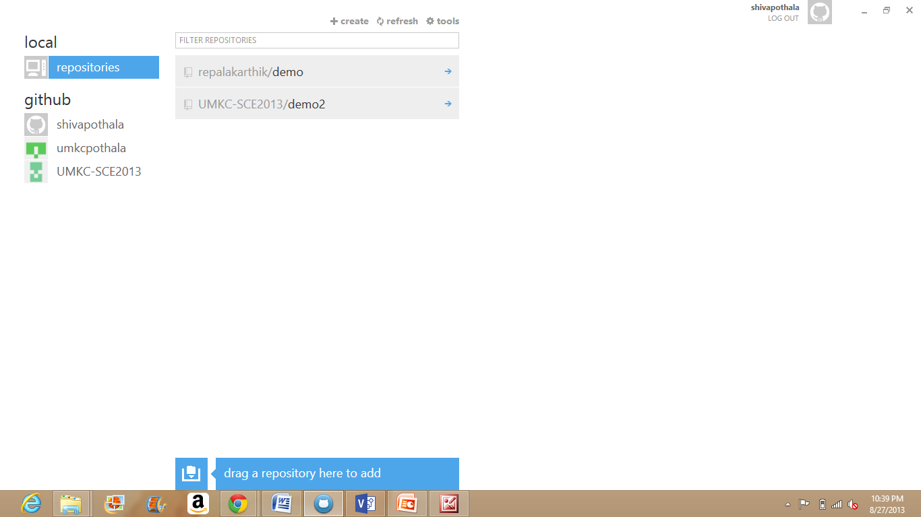

Logged in as different team member and launched application by clicking the Clone in Desktop button

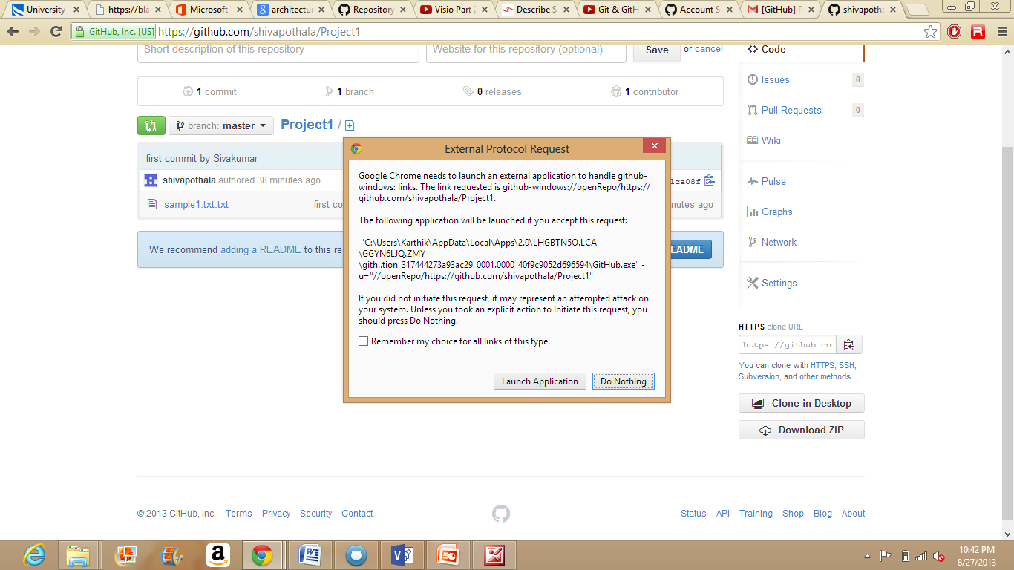

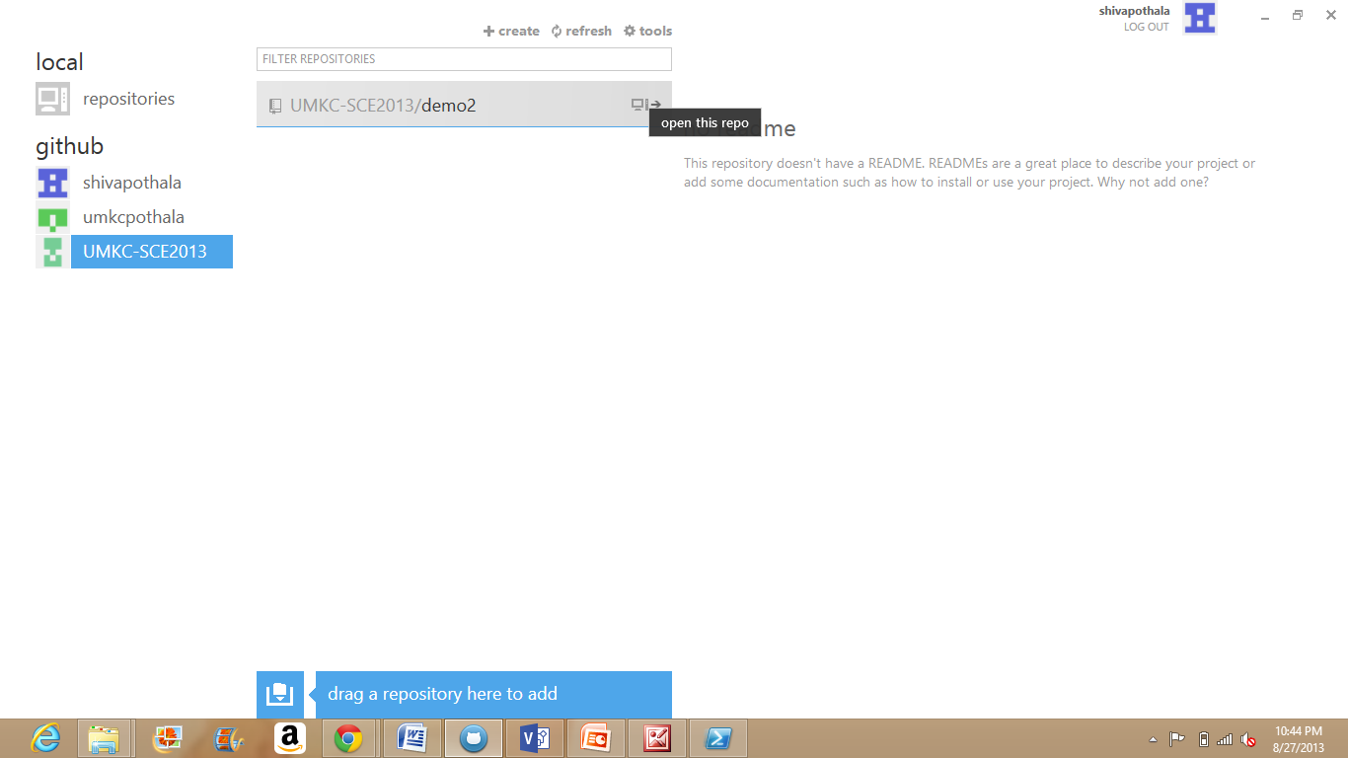

Before the second team member changes.

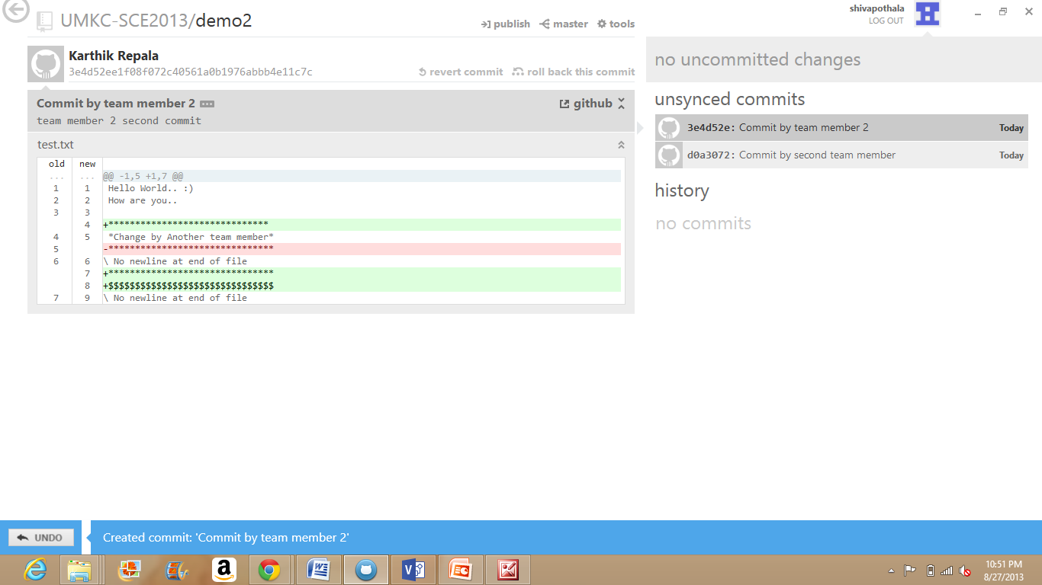

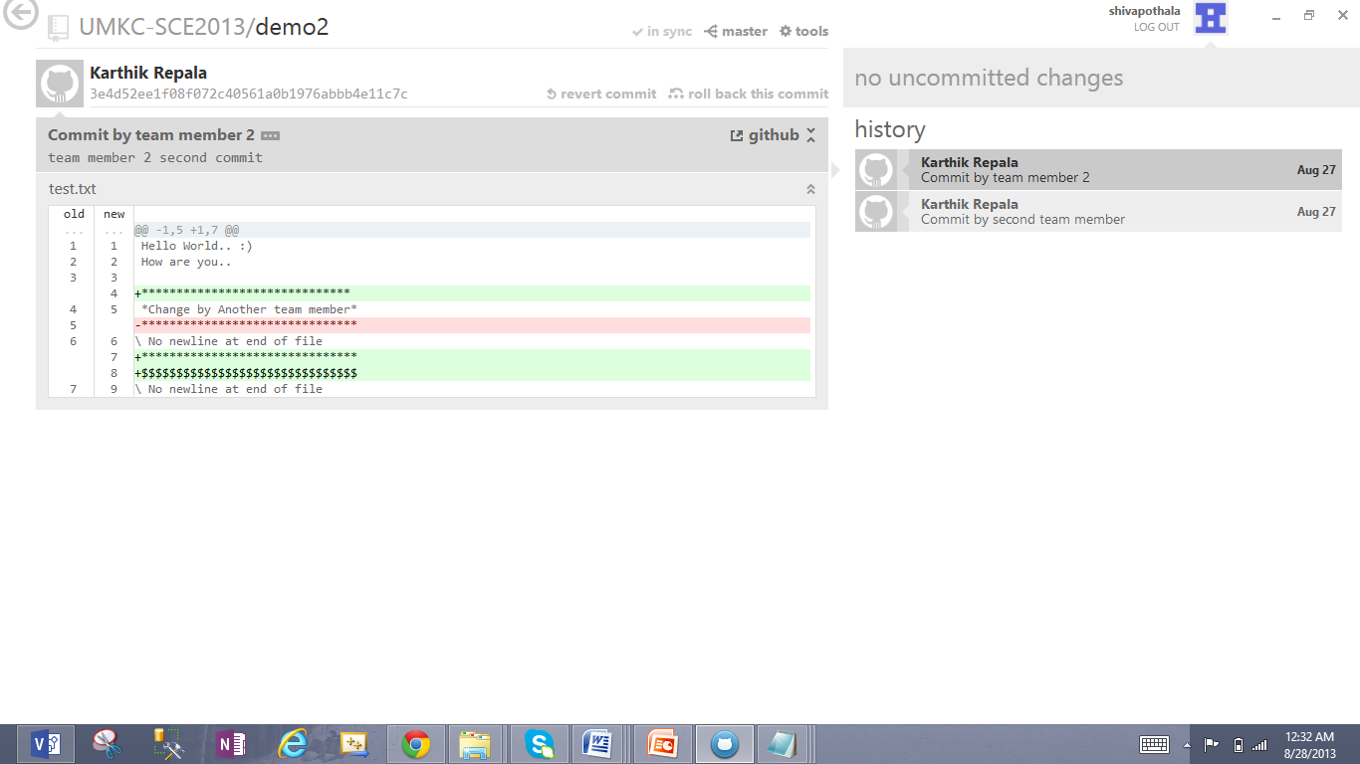

After the changes made to the file,

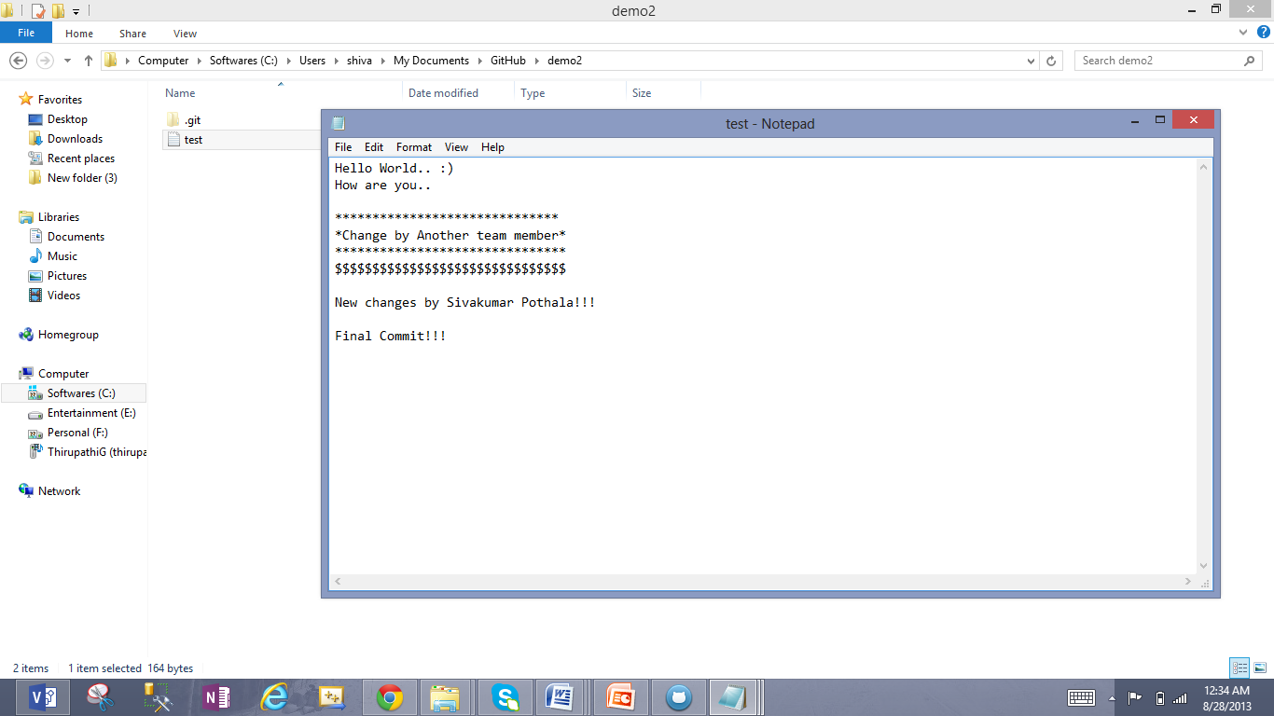

Change made and Commit done by another team member.

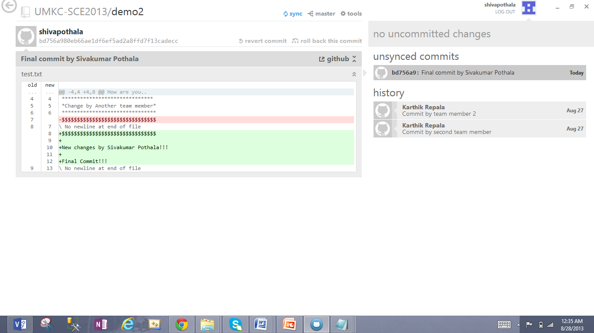

Last step, Sync the file which is committed above.

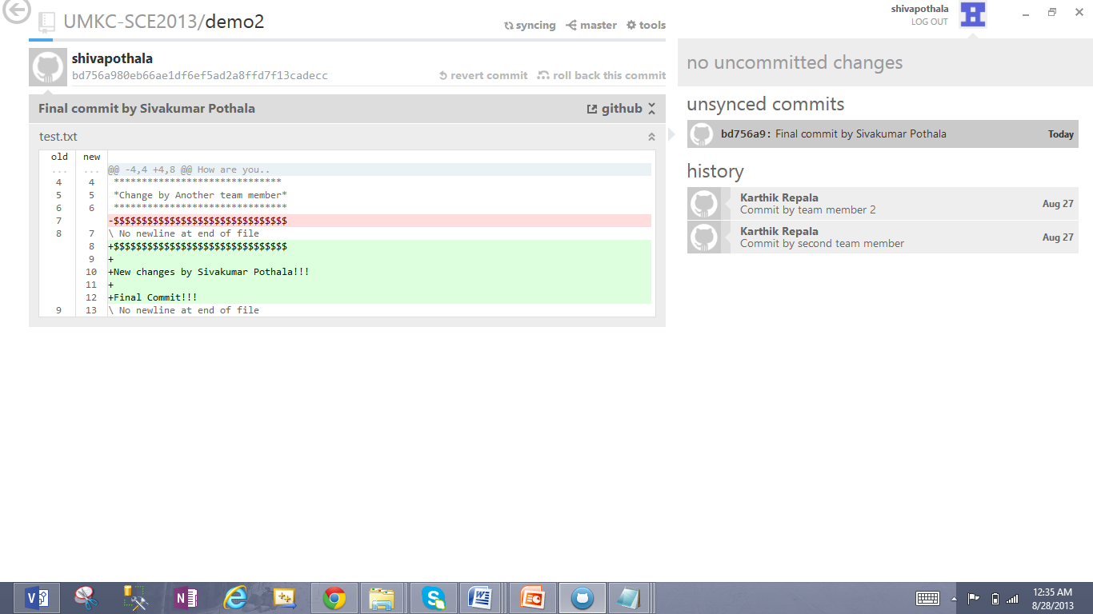

The Status shows as In Sync.

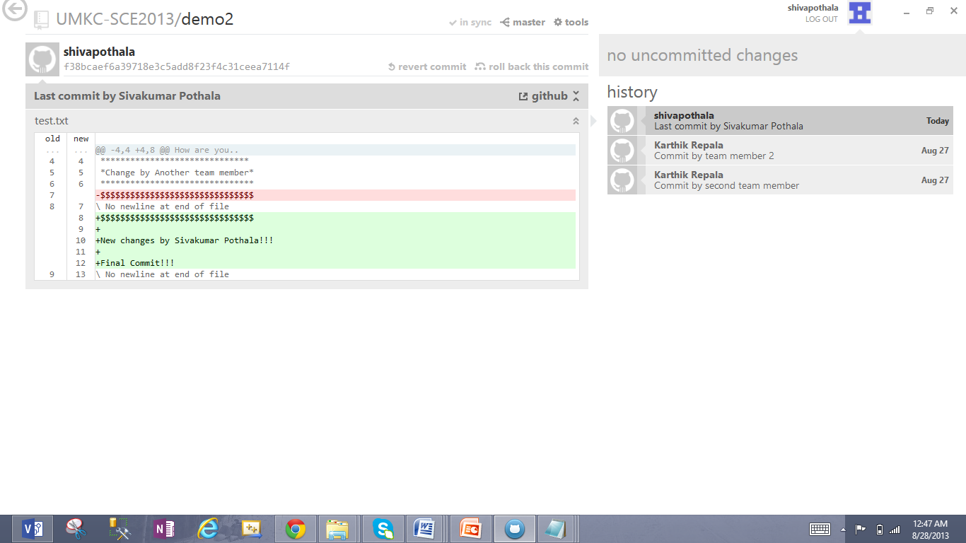

UML DIAGRAMS

3. For a given problem description (refer to the blackboard/Tutorials/Lab1), design Class diagram, Sequence diagram and Architecture diagram using Visio.  
Write a short report on your work (including screenshots) and post it to your GitHub site. And post the link to "Link to Report" in the Google spreadsheet (above).

A product is to be installed to control elevators in a building with m floors. The problem concerns the logic required to move elevators between floors according to the following constraints:

Each elevator has a set of m buttons, one for each floor. These illuminate when pressed and cause the elevator to visit the corresponding floor. The illumination is canceled when the elevator visits the corresponding floor.

Each floor, except the first floor and top floor has two buttons, one to request and up-elevator and one to request a down-elevator. These buttons illuminate when pressed. The illumination is canceled when an elevator visits the floor and then moves in the desired direction.

When an elevator has no requests, it remains at its current floor with its doors closed.

The basic course of Action for elevator scenario:

* Passenger presses floor button (that is the button on the wall).
* Elevator system detects floor button pressed.
* Elevator moves to the floor.
* Elevator doors open.
* Passenger gets in and presses elevator button (that is the button in the cabin panel).
* Elevator doors close.
* Elevator moves to required floor.
* Elevator doors open.
* Passenger gets out.
* Elevator doors close.

1. Using Visio, draw the Class diagram for the elevator system

**Solution:**

In order to draw class diagram for the given scenario I considered six classes, Elevator, Elevator_Controller, Door, Button, Elevator_Button and Floor_Button.

Elevator_Button and Floor_Button are the dependencies of Button class hence there is a Generalization button.

Button class and Elevator class are part of Elevator_Controller class

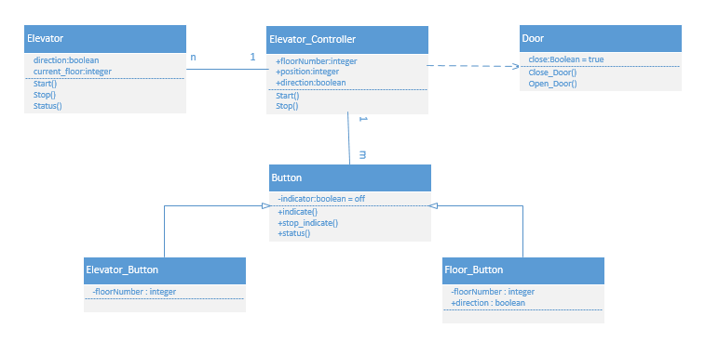

1. Using Visio, draw the Sequence diagram pertaining to the floor button

**Solution:**

Passenger uses the floor button in order to control the elevator.

The process of steps can be shown in the below diagram.

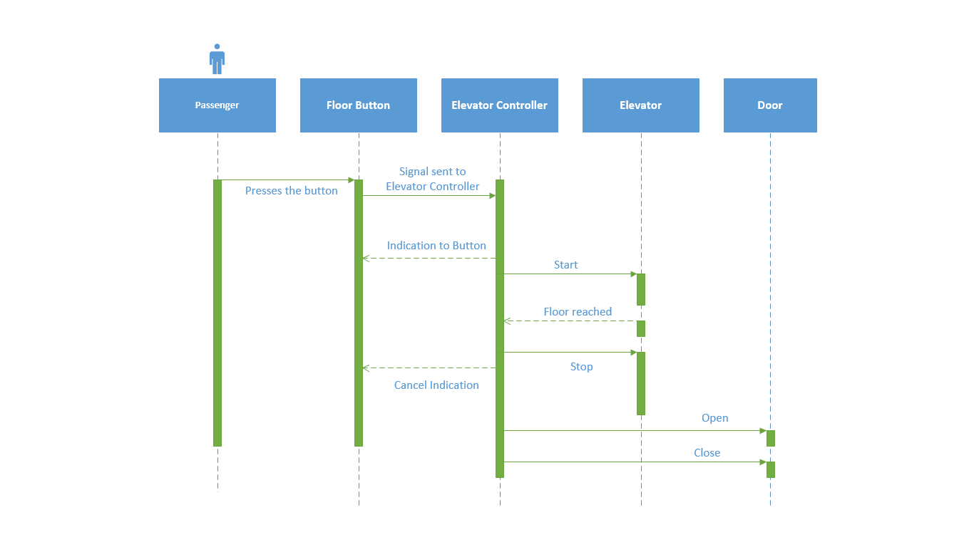

1. Using Visio, draw the Architecture diagram for the elevator management system

**Solution:**

Architecture refers to the big picture of the system.

It is a pattern in which individual objects are arranged systematically and also talks about the flow of information.

There is an elevator controller and two elevators present in the below diagram.

There are two persons who presses the elevator button in order to control the lift.

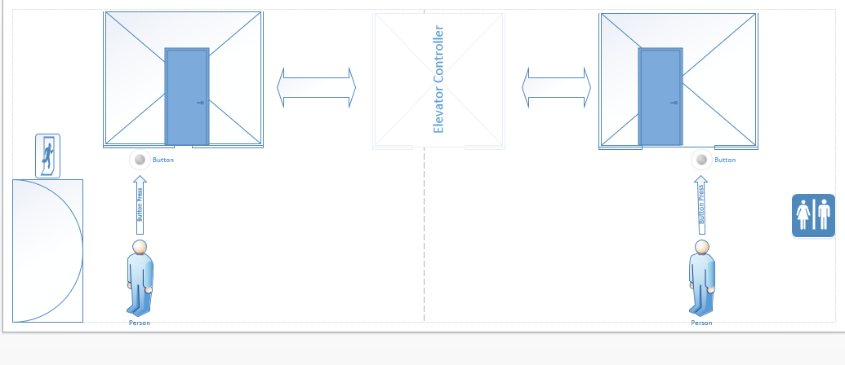

The attachments to the diagrams are here-

